Manhattan Borough Historian
Michael Miscione Invites You To
WHEN
Sunday, November 19, 2006 at 1:00p. (If rain threatens, check www.andrewhgreen.net.)
WHERE
The Andrew H. Green Memorial Bench, inside Central Park at about 105th Street. Be warned, the bench is extremely difficult to find and is not marked on most park maps. Follow the directions below or consult the map at www.andrewhgreen.net.
FREE
Free and open to everyone. No reservations required.
QUESTIONS
For inquiries about the event, call (212) 669-8089, or write to boroughhistorian@
manhattanbp.org.
LEARN MORE
To learn more about the remarkable career of Andrew H. Green, visit www.andrewhgreen.net.
DIRECTIONS TO THE
A.H. GREEN BENCH
See below, or visit www.andrewhgreen.net for complete directions and a map.
At Fifth Avenue and E. 102nd Street, enter Central Park via the automobile entrance road. Bear right, merging on to the main drive. Continue walking north on the drive for about two blocks. When you come to the standing three-sided map on your left, turn left on to the wide, well-paved crossover road that heads to the West Side. Take an immediate right turn on to the blacktop footpath that heads uphill. Bear right as you walk along the path. The bench is at the top of the hill.
A TRIBUTE TO
ANDREW H. GREEN, NYC’S FORGOTTEN
CIVIC GIANT
NEW DATE:
SUNDAY
NOV. 19

Join us in Central Park on Sunday, November 19th as we raise a toast to Andrew H. Green, the unsung 19th century master planner, reformer and preservationist who transformed New York into a world-class city.
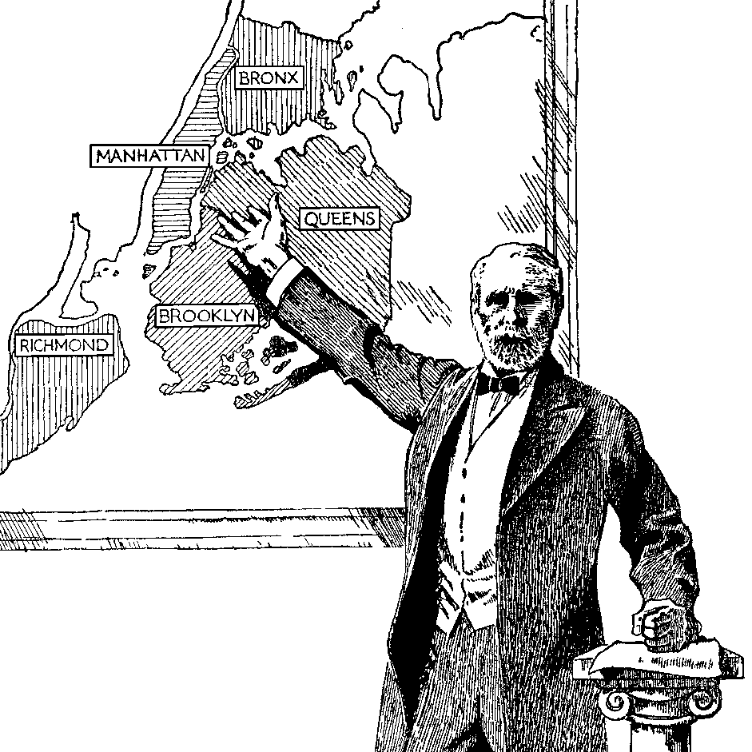
“… arguably the most
important leader
in Gotham’s
long history.”

Kenneth T. Jackson
Editor, Encyclopedia
of New York City
During his fifty-year career,
Green steered the creation of
New York City’s foremost parks,
cultural institutions and public works. He rescued the city from bankruptcy after the Tweed Ring scandals, and pioneered the historic preservation movement. Most importantly, he masterminded the 1898 consolidation of the five boroughs, a measure that expanded the city’s size fivefold.
Visit www.andrewhgreen.net to learn more.

